West Hull Ladies
RRC

July Newsletter

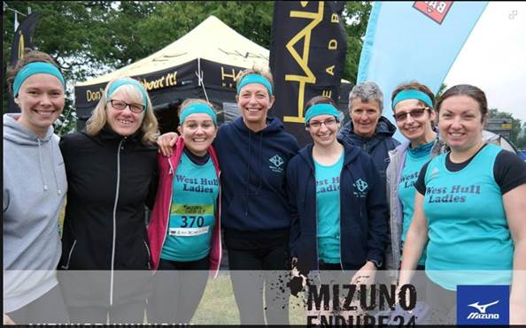

Endure 24 2015

West Hull Ladies

WEST HULL LADIES COMMITTEE MEETING

6th July 2015
Present - Jill, Zoe, Sandra, Karen, Linda, Amanda, Anna, Maria
- Apologies from Annette, Jan, Liz, Rachel
- Minutes of previous meeting accepted as true record
- Matters arising - Karen continuing to produce document explaining Power of 10 & Run Britain & Run England, also club name should be West Hull Ladies not West Hull Ladies RRC. Karen to continue this. Karen updated about Facebook members - membership had been reduced from 158-114. The committee thanked Karen for this. Vests dealt with item 4 and GBR item 5. Karen updated the committee about leaders and coaches being DBS checked. Each leader could check their profile on England Athletics via the portal. It was very easy to complete online and Linda and Karen were both ‘verifiers’. Karen to progress with leaders not checked.
- Vest - several ladies had tried out the vest and reports were that they liked it. Sandra to progress
- GBR - the event had been cancelled this year due to difficulties with Guinness and the world record attempt. Club members had been informed. Karen to remove pinned post from Facebook.
- Jill updated the Committee about the benefits of purchasing an event tent. The Committee agreed to the purchase. Jill to progress this and purchase in time for it to be available for Thunder Run.
- Amanda had received information about Yorkshire Vets Cross Country Championships to be held nr Whitby on 19th September. Discussion on whether we should stay members - agreed we would as cost was minimal and in time ladies may wish to compete. Jill to make enquiries to ascertain if Ladies wanted to run this year.
- a) Amanda informed the group that Victoria Voase who was no longer a Club Member was a bank authoriser. Jill to contact Victoria and explain how to have her name removed from the bank details for the Club.
b) Edinburgh Marathon had been in touch about securing guaranteed club entries to the Marathon. Members felt this had never been an issue and we would discuss it further at the meeting in August.
c) Amanda had not received many volunteers willing to attend the meeting on the 20th August concerning the water station the Club had been allocated for the Hull Marathon. This would be brought up nearer the time when ladies had a better idea of their commitments. Hull marathon had also given the Club a t-shirt to promote the event. Jill took this to wear at the Thunder Run. Amanda to contact the organisers to see if they had any leaflets that could be distributed at Thunder Run.
d) Newsletter - deadline for articles for the newsletter would be the Friday following the committee meeting. Amanda to send email informing members (done)
e) Amanda had spoken to Dean Latus about our continued use of the Club. The Latus brothers who own the club were unaware of any agreement between the sports hall and the Club. Amanda to email them with our requirements.
f) Amanda informed the Committee that Karen would attend the LiRF (Leaders) course on Sunday. She thanked Karen for volunteering to lead her first training session on Monday 27th July.

Meet a Member: Sandra Holdsworth

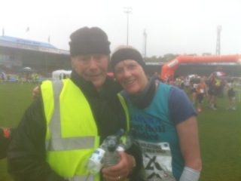

Age: 58

Member of WHL since: 2011 (?)

What do you do when you’re not running?
I run a hotel for my daughters and Husband or that is what it feels like! Since I retired I never seem to have much free time - I do like knitting, reading and lunching with friends when I get chance.

How long have you been running?
I came from a running background and so started when I was about 6yrs old. My distance was 800m. When I was about 16-17 I retired but continued running on and off. In 2011 I decided to join West Hull Ladies as I was fed up of 'plodding' and not making any progress. One of the best things I ever did.

Why did you start running?
Family tradition and as my Dad was also a runner and coach I had to.....

Favourite distance?
I am not sure as whilst at the minute I feel marathoner out once the training is done I do love the race. I love the fact that it is so unpredictable - you just never know what is going to happen and it is such a good feeling having done it
Favourite bit of running kit
At first I was going to say I didn't have one but yes I do - my Garmin. I love downloading my runs - especially those done whilst on holiday. I would love to run without it though but just can't. How sad is that.

Any injuries?
At the moment I am suffering with a foot/ankle/instep injury. Not sure if this was caused by new trainers but it is improving and I am trying to be good and do all my exercises. I have also started swimming again and will be out soon on my cycle.

Running goals?
After London Marathon 2016 I would like to improve my 10k time. I am really looking forward to doing the training for that specific distance. Really looking forward to it. As I am getting older I am also maybe thinking that in the next couple of years I should do a coaching course. (Did I really say that!)

Proudest moment running related or otherwise
Thunder Run 2014 was a fabulous experience. I was so proud to be a member of such a wonderful Club. To see and experience us all working together for a common purpose - to help and encourage Sally and Zoe in the pairs team was something else. I was so proud of the girls winning and the ladies helping.

Best piece of advice you’ve received
When I was racing I always looked at my Garmin and thought 'slow down you are going to fast'. I then read a book by Julian Goater on how to run faster. He said that you shouldn't think that - you should just go for it and if the worst came to the worst all that would happen is that you would slow done. This is so true and by doing that I achieved a PB.

Running alone or with friends?
Both really. One aspect of running that I love is that i can just run from the door in beautiful countryside and I have the freedom to go when I like. However when I do go to the Club I realise how much I do miss the wonderful members and I know if I went more often I would improve. My father is also a great running companion. He always used to run with me but as he has got older he now cycles alongside me. I just love those father and daughter runs.

What keeps you motivated?
I just love the freedom running gives you - just to be outside in the fresh air enjoying the beautiful country we live in - how fantastic is that. Hate the blinking weather at times though!

Meet a Member: Tracy Toner
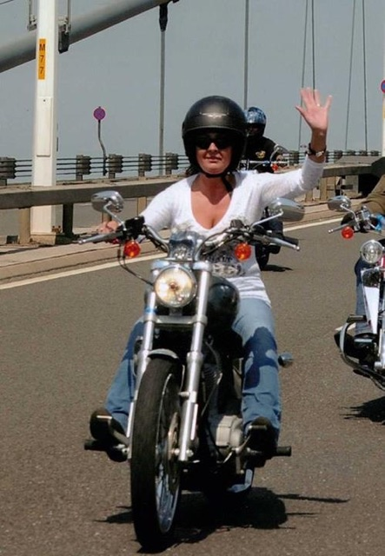

Age 49 …. the big 50 in November ….. eek!
Member of WHL since
August 2014 … nearly 1 year and I’ve loved every minute
What do you do when you’re not running?
…. ha … fancy asking a women this … they do everything! I work full time as an Enterprise Support Officer at Hull City Council on the Green Port Hull Project which, basically means that I’m involved in the Siemens development and bringing Inward Investment into the City. I’ve been working for HCC for nearly 12 years on all different kinds of projects.
I’ve been married for nearly 27 years to my best mate Phil, we do everything together. We have one son called Jake, he’s at Hull Uni studying Biology, he’s a member of Mensa with an IQ of 149 … and, who does he take after I hear you say … definitely not me, I try telling him he gets his brains from me but he’s not convinced. We also have a Staffordshire Bull Terrier called Mojo, she’s 14 in November and has been very ill recently but she seems to be ok at present (touch wood)!
Other hobbies besides running, I go to the gym when I get time. I ride a Harley Davidson 883 Sportster, I think I went through a mid life crisis about 3 years ago, decided that I wanted to take my bike test and have a bike so I did. My hubby also rides a Harley, we go to bike rallies together, camping …sometimes in the mud, listening to some great music and meeting some great people. I don’t think I could ever go back to being a pillion again! I also like cooking/baking and knitting … all when I get some spare time which, isn’t very often.

How long have you been running?
On and off for about 20 years, my husband got me into it. I have always done some kind of sport – gym, aerobics etc. but I seem to get bored of these quickly and always go back to running.
Why did you start running?
I love the fact that I can run when I want to and it’s cheap … saying that since I’ve joined WHL I seem to spend more money on running gear than any other gear … my hubby keeps on telling me that I can only wear one pair of trainers at a time, I just tell him I like a choice and the ALL the other girls have far more than I do.
Favourite distance
10k although I do enjoy half marathons .. I’ll tell you if I enjoy a full marathon after 13/9.

Favourite bit of running kit
That’s easy, I’ve just purchased my first pair of injinji toe socks, these are awesome, they look hilarious but they are so comfortable plus I now don’t get unexplained blood stains on my socks/trainers … I think my toes were rubbing/nipping together which, they can’t do in my toe socks.
Any injuries?
Oh my where do I start – broken right arm and thumb from falling off a horse; broken right ankle … 4 times … yes, 4 times … first time I fell down a hole whilst running; second time I fell off a step box whilst doing step aerobics; third time I just tripped over whilst on holiday in Morocco and the fourth time I fell off the window sill whilst cleaning the windows. Left ankle I sprained in November last year fell over whilst on a work trip in Belfast. Now you know why I’m not very keen on ‘off road’ running.

Running goals?
To finish the Hull Marathon … I’ll warn you I will cry!
Proudest moment running related or otherwise
Too many to name – getting married, having our son, getting a 2:1 degree at Hull Uni whilst working full time and looking after a family and passing my full UK bike test. And, also a solo parachute jump when I was 29 which was awesome.

Best piece of advice you’ve received
Aways believe in yourself and never give up.

Running alone or with friends?
Definitely with WHL

What keeps you motivated?
WHL!

Me on my Harley (Gerty) at HOG on the Humber in 2013 raising money for charity. If any of you are interested this event (13th HOG on the Humber rally) will take place on Sunday 12th July at the Humber Bridge Carpark … lots going on.

Tough Ten : Linda

Another rainy race! Met up with Barbara and Jane at Humber Bridge car park and travelled to the Swallow Inn for this race. It rained before the race but settled down to a dreary drizzle during and then started raining heavily at the end. It was humid though. I did enjoy the race not sure enjoy is the right word for the hills they chuck in though! After lots of trouble with the results due to the timing chips falling off some shoes or not activating the finish mat we finally got the results through today. I managed a better time than last year which was 1:29:33 and this year was 1:28:23 (both chip times), last year I was third in my age category and this year second so well chuffed with that.
Barbara came in at 1:41:03 and Jane came in at 1:52:53 and it was wonderful to see the lovely smile of Mary Carrick from East Hull Harriers after her CL victory on Tuesday she came in at 1:49:01.
Lovely to spend some time with Barbara and Jane and we all enjoyed the cake at the end too!
Linda

Jane Tomlinson Hull Ten k : Ruth

I know there are West Hull Ladies doing really epic races this weekend, so really well done to them, and really impressed by what they have achieved.
I however crept out of the woodwork to do this race, and here’s my report........
I came out of running retirement about 6 weeks ago because I had a christening to go to, and a ‘snug round the hips’ dress to wear for it. I managed to get into the dress and popped my trainers away a fortnight ago. Then last week I decided it would be really good to act as ‘running buddy’ for my step-daughter in law Sarah who was running the Jan Tomlinson for The National Autistic Society, so I signed up. Sarah had promised me she was going to run/walk it, so i reckoned I might be ok.

It was a damp morning, fortunately not too hot, so ideal for running. It took us 5 minutes to get to the start line and then we were off. The marvellous Sharron was standing near North Bridge to cheer us on. It was such a lovely surprise to see (and hear) her. We ran a fair bit then slipped into run/walk mode. Saw Karen well ahead of us going ‘the other way’ on Victoria Dock, and got greetings from other West Hull Ladies. We had a pleasant run, greeting marshals, generally chatting etc, and we would have been quicker if we hadn’t stopped at the loos on the Marina and if I hadn’t gone back (twice) for jelly babies from the 2nd water station. As we were running through town all the people who had finished (and were going home) were cheering us on and saying how well we were doing – really lovely. Sharron and her husband Nige were at the finish line to cheers us in, full marks (and big hugs) to them for sticking it out.
Sarah thinks she may do it again next year, but maybe with a bit more training for both of us.
I’m afraid I must admit that 2 people commented on seeing a WHL walking, so apologies all round ladies if I’ve brought the WHL name into disrepute............or maybe it just shows what an all-encompassing and welcoming club WHL is...............yeah, definitely the second option.
I’d like to say that I’m going to keep my trainers out of the cupboard and start running with the club again, but ‘life’ has a habit of getting on the way, well, we shall see.................
Ruth

Owston Ferry Ten k : Linda

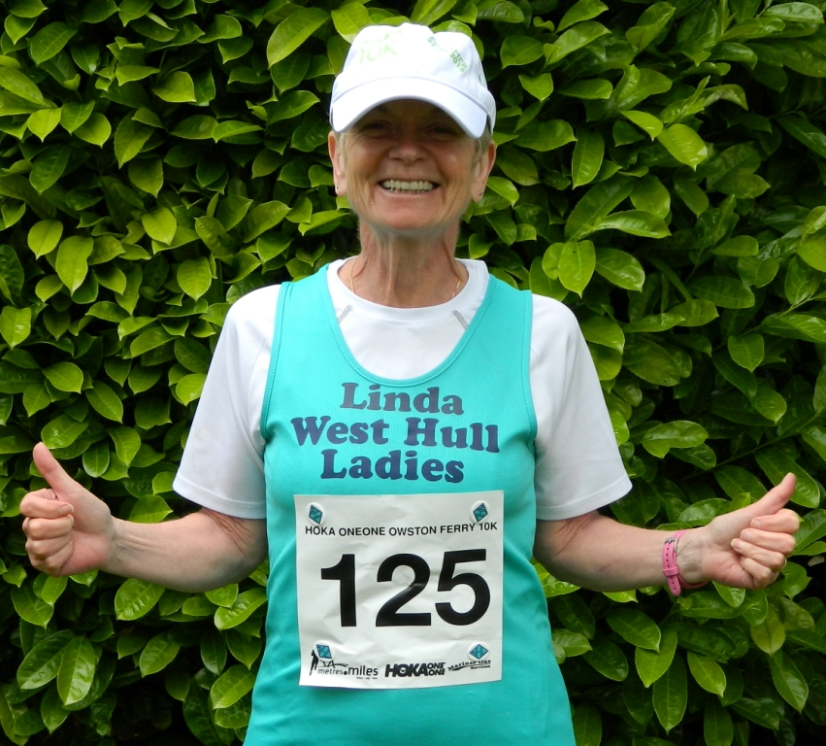
A lovely morning for a run and I was so looking forward to this race as I was very envious of the T-shirts that Sandra and Amanda sported last year.
Well I woke up but wasn’t feeling ‘myself’, I had started with a ‘ruckle’ type cough on Friday but I thought I was ok, tried not to cough in front of hubby or he would have banned me from running. If Sandra had heard me I’m sure she would have sent me home too!
Anyway after a good cough in the car and two magic pills off I went to the start. The start was a bit hemmed in I thought, cars parked, cars trying to move and people, oh boy lots of runners. Well I was only using this as a training run for my marathon training so not to worry, oh and no chip type fancy timing either I hadn’t even realised that we’d set off properly! Still it was a lovely day and I wasn’t feeling too bad. I needed to stick to my training plan and it was supposed to be a steady 7 miler at around 9.02 pace. I knew I was going to be a bit short but I could correct that later with a good old dog walk so tried to settle into a steady pace. Well the slowest mile I did was 8.46 and that was because I was coughing like an old man who had just smoked 20 Park Drives! Not good and I felt a little bit wobbly too. Still not long before the finish was finally in sight. Saw Rich Harrison taking photos of his club mates and more importantly Sarah (his girlfriend) who was also running. Not sure of my time but I think it was around 53mins. If it hadn’t been for the strong gusty winds (again)! And for this darned stupid cough I know I would have got a PB.
Rushed off back to the car to beat the Tractor Rally that was due to start in Epworth and I’d seen them all arriving when we drove through the village, didn’t want to get stuck behind them as I had to get home to get the dinner on for the Father’s Day visitors that were due! It’s all go for us girls isn’t it!
Oh and the fancy t’shirt didn’t materialize either, we were given a baseball cap. I know I look a right Charlie in one of these, see attached!
Linda
Endure24 race report: Liz
Work has been really busy lately, so I didn't really have a chance to properly think about Endure24 in the build up to the event. Luckily this meant I didn't really have time to get nervous, and even more luckily, everyone else was so organised that all I had to do was turn up! But as I was walking home from work on Thursday evening, I realised that I was about to spend a WHOLE WEEKEND running around in the woods. What could be better?
I arrived at Sarah King's house first thing on Friday morning. My bags were put in the caravan for me, I was given a delicious cup of coffee, and then Sarah's husband Nick drove us down to Reading (I don't think I did anything for myself all weekend - thanks ladies (and Nick!)). The car and caravan were seriously laden down with tents and carbohydrates, so we made slow progress. When we arrived, we found that the City of Hull guys had saved us a big space on the campsite, so we proceeded to show them up by setting up our caravan and tent much quicker than they'd done theirs.
Just in time, too - it soon started chucking it down, so we made our way to the main tent to register and pick up our t-shirts, and had a cup of tea while we waited for the rain to stop. But then, disaster! We got back to the Hull camp to find that the tent had collapsed under the weight of all the rain. We sorted it out pretty quickly, and luckily not much water had made it inside. My sleeping bag had got quite wet, but Sarah came to the rescue with the spare one she happened to have in her bag of tricks. A running theme of the weekend was that any time anyone needed something, Sarah had it to hand. Cup of tea? Hair grips? Sleeping bag? Table and chairs? Sarah had it all.
It rained again in the night, but I slept like a log, blissfully unaware that everyone else was having a terrible night's sleep. Zoe only slept for three hours - not what you need when you're planning to stay up for 24 hours. But before we knew it, it was time to start running. Trish ran the first lap for team Thunder and Lightning (followed by Sarah, Verity, Sandra and mum), and I was up first for Thunder Girls Are Go (followed by Zoe, Jill and Debs). The 8km course was lovely. Starting off with a road stretch surrounded by rhododendrons, the first half was mostly undulating woodland trails. There was a rather unpleasant hill at 5km, but the final 3km were great - downhill trails through the trees, just wide enough for one or two people, with plenty of tree roots and rocks to avoid. My favourite.
The first lap was quite slow, but as the runners started to spread out we soon got into our stride, and the laps started to tick by. To be honest, most of the next 24 hours are already a bit of a blur in my memory. A few things stand out, though: the organisers had decked out the trees with glow-sticks and fairy lights, which was a nice boost in the middle of the night; at 4am, the chorus of birds singing was a real treat; and I'll never forget hanging wet bras on a tree at 2 in the morning, vainly hoping they'd be dry by next lap! I think we all had our ups and downs (I know I cried when the catering tent ran out of veggie burgers), but everyone was amazingly cheerful and supportive of each other.
By the time the sun was properly up, we were approaching the last few hours, and Thunder Girls Are Go had run six laps each. Zoe and I worked out that as long as we ran out seventh lap really slowly, we wouldn't have to do another one. What a relief! So off I went for lap number seven, safe in the knowledge that I would never have to put myself through this again. Or so I thought. I thought I was running slowly, but apparently not slowly enough - it turned out I felt absolutely fine, and I finished my lap in 58 minutes. In the end, we decided to just go for it, and I ended up running an eighth lap. I ran most of it with Sunny from City of Hull, and we crossed the finish line together. I'm so glad we didn't give in to the despair, ladies! Well done everyone!
In the end, Trish, Sandra and Sarah ran 20 miles each, mum ran 30, Verity, Debs, Jill and Zoe ran 35, and I just about managed 40. We are all mad, and we should all be very proud of ourselves.
So what did I learn? More miles = more fun! But next time I'll take more socks and bras. And on a serious note, I learned that West Hull Ladies are even more ace than I thought. Thank you so much for running with me and looking after me this weekend, ladies. What a privilege to be in this club.
Thanks everyone,
Liz
P.S. Jill - sorry, but I think I'm going to be taking the Thunder Run quite seriously
:-)

Endure 24: Jill
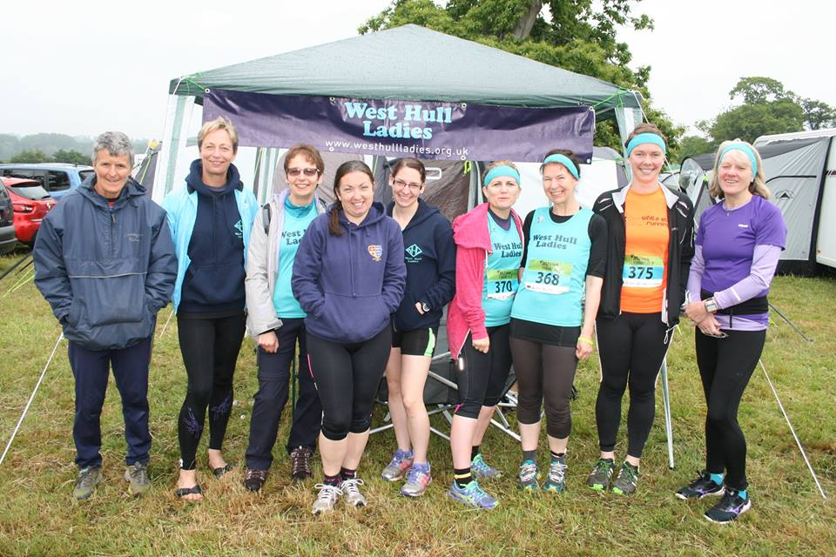

This was the first time that we had been to Endure 24 with a team of runners. The reason why we ended up going was mainly as we did not get some of our teams into the Thunder run event, due to difficulties with the system of entry, so we ended up entering a couple of teams into this event.
Like Thunder run, Endure is a 24 hour race in which you can enter as a solo, or teams of up to 8 competitors to take part in a relay. The race starts at Saturday 12 noon and finishes on Sunday at 12 noon. We had a team of 5: Sandra, Jan, Trish, Sarah and Verity, and a team of 4: Zoe, Debs, Liz D and me.
Endure 24 is situated near Aldermaston, which is over 4 hours drive, so we were a bit concerned with how we might deal with the drive back after having run through the night! Luckily Sarah’s husband volunteered to drive some of the team there and back as well as taking their caravan down. The others either went in my car or got lifts with City of Hull, who were brilliant in saving us a great spot on the campsite. When we first arrived the weather was horrendous, which resulted in the tent collapsing, although this was mainly due to the fact that we had not really erected it properly. It was nice to have the caravan as a base, particularly when it was wet, but fortunately the weather did improve throughout the weekend, and temperatures were good for running.
These events are always a good laugh even though they are also challenging, and we enjoyed having tea under the gazebo on Friday evening and also walking around the 5 mile circuit which was really quite picturesque. The event itself was really great, and our runners did us proud. The team of five ran at least 20 miles apiece with Jan doing 30 miles and Verity 35miles! This was despite Sandra, Trish and Sarah suffering a variety of blisters, injuries or exposure to the cold! The team of 4 all did 35 miles, with Liz doing a massive 40 miles, yet still looking as though she would carry on for ever!
If you want to see more details about our experiences:
https://www.youtube.com/watch?v=p_TXkMh2iVM is an 18 minute film of the teams exploits at the event with a commentary.
https://www.youtube.com/watch?v=aoLo82pq1Ag is a 6 minute film of me going around the lap of Endure, with a commentary.
This was a great event, which I am sure people will want to do next year.

Burton Pidsea 10k – Jermaine

Super organised Jane picked me up at 9am (she wanted to pick me up at 8:30) but with the race starting at 11 am there was no way I was leaving the house any sooner than 9! When we got there we were the 1st at the car park - (little surprise there) but not the 1st ones to pick our numbers up. Once our numbers were collected and pinned tightly to our vests (yes it was windy and I didn't want it blowing away) we sat down and had a coffee and shared a kit-kat. Jane chatted to another runner that she had met on the tough 10. After a while we decided to drop our things off in the car and make our way all 1.5km of it up to the start line. Jane had a few niggles in her quad and I could see that she wasn't her best (this is her least favourite run) At the start we did our dynamic stretches!! and a few static ones. Another lady showed me a really good hip stretch so I was on the grass doing something resembling a 'swan' as Jane named it, when Jane spotted Sarah T, Sara & Rachael. So we chatted to Sarah then went over to stand with Sara & Rachael to wait for the start.
Both Sara & Rachael went off like rockets! I kept them in my sights but there was no way I was catching them. It was one of those rare races where even though it was windy and hot everything seemed to go smoothly. I kept an even pace and even managed negative splits for the last 2k over-taking a few people on the inclines.
I didn't expect a sub 50 ! and it wasn't until the last 1km when I looked at my watch and thought if I can push it, I might just do it. I crossed the line at an official time of 49:48 and was completely stunned. Everyone was amazing and managed to surprise themselves. Jane managed to improve on last year's result by almost 3 minutes and has made such a vast improvement since our 2013 race in spite of hating the course. Well done ladies, you are all brill! P.S. Rach can you send the pic your son took of us all x
There was nobody in the 55-60 category so if anyone wants to do it next year you might be in for a 1st in age category. I have to also say that the marshals were great and the villagers were out on the streets applauding us, which is always lovely!
Jermaine

Liz's 50th Park Run

The day started out like any other Parkrun. I had just set off with the intention of hopefully knocking a few seconds off my PB, like you do! However as I was running past the finish line for the first time I heard a cheery "Hi Liz!" and I looked round and there was Karen. "Hi Karen" said I, "it's my 50th parkrun today" "Oh", says Karen "you want to break 30 mins on your 50th Parkrun don't you?" , "Yes" I replied but actually thought "in my dreams!" at which Karen says to me "Right then no talking, I'm going to get you round in under 30 mins, I'll do the talking!" Well with that we upped to pace a little, Karen told me to concentrate on the breathing and to listen to her, at first I found I could keep the pace up quite well, my fast mile and fast 1km training on Monday nights was kicking in. My first bad point came as we went past the bridge, keep going says Karen " I know you can do this, I've seen you do it in training", I smiled at that as I am normally so far behind Karen, in training I felt she was using her imagination in this respect! We then went past the finish and achieved my first aim which is always to complete the first lap without being lapped, by the leaders.
Karen then said we needed to up the pace a bit, I was a bit worried about this but Karen said, "My breathing was great!" I was more worried about the legs I have to confess as my thighs were starting to protest. I have found that as I have run more and with the fast training, I can carry on without them or me for that matter spontaneously combusting! (Always a concern when I first started running). Karen started to pull a little ahead and again as we went past the bridge, the effort must has shown in my breathing, she told me to count every breath up to 100, surprisingly this steadied my breathing and I could keep up the pace. As we ran on the pavers just after the animal enclosures, she said to me "we are nearly there, and are going to do a sprint from the bollards round the last corner, "Yes" ! said which was partly because, "You're having a larf!" was too much effort to say. I tried increasing the speed of my arm movements in the hope of increasing my pace, and the welcome sight of the finish came into view, "Come on Liz" Karen shouted, "you are going to run past me, Come on!" Amazingly I managed it, with a little assist from Karen, (I suspect). Even more amazingly although I expected a PB, I had beaten the magic 30mins, by 5 huge seconds!!
We got our barcodes at which Karen, said "Brilliant well done, but I need to go and help Amanda now!" So off she ran back onto the course. Guess what Amanda got a PB too!

Just to say a massive thank you to "Coach" Karen, I always thought I might get somewhere near to 30mins but not this soon, thank you for making my 50th parkrun so special!
Liz

2015 RACE DIARY
http://westhullladies.org.uk/races.htm
Free 5K time trial every Saturday 9am: Hull Parkrun or Peter Pan Parkrun Humber Bridge parkrun

July 2015
 | 5th/10:00 | Caistor 10K | £10 UKA/£12 | Online entries only | online entry
 | 5th/10:30 | Harrogate Town Centre 10K | £10 UKA/£12 | Online entries only | online entry
 | 10th/19:30 | Walkington 10K | £11 UKA/£13 | Online entries only | online entry
 | 12th/09:30 | Jane Tomlinson Leeds 10K | £25.82 UKA/£27.96 | Online entries only | online entry
 | 19th/10:00 | Burton Constable Hall 10K Trail Race | £15 UKA/£18 | Entry form | online entry
Aug 2015
 | 2nd/09:30 | Jane Tomlinson York 10K | £25.82 UKA/£27.96 | Online entries only | online entry
 | 16th/11:00 | Escrick 10K | £12 UKA/£14 | Entry form | online entry (+£1.70)
 | 23rd/10:00 | Major Stone Half Marathon | £18.20 UKA/£20.20 | Online entries only | online entry
 | 30th/09:00 | Jim Dingwall 10K | £13 UKA/£15 | Online entries only | online entry
Sep 2015
 | 13th/09:00 | Hull Marathon | £35 UKA/£37 | Online entries only | online entry
Please remember to double check dates, times and entry fees with the official website or the entry form. Keep checking the website for new races and updates:

NOTE: Club Vests must be worn at any races you enter under the West Hull Ladies running club name.
West Hull Ladies Road Running Club
Kit Order Form

FORENAME ___________________________________

SURNAME ___________________________________

ORDER - tick what you require and circle your size Price
- VEST SIZE 10 12 14 16 £16.00
- LONG SLEEVED SIZE 10 12 14 16 £18.50
- HOODIE SIZE XS S M L £20
- HOODIE with ZIP SIZE XS S M L £20
Note on size, M is approximately size 14
- BEANIE HAT £6.50
- PINLESS WHL NUMBER FASTENERS (set of 4) £3.00

DATE Ordered _______________

AMOUNT PAID _______________

Please transfer payments online with your name and marked as ‘Kit to:
Account: 63762742 Sort Code: 20 43 49

Or cheque payable to ‘West Hull Ladies RRC’, and write your name and ‘Kit’ on the back and give to Club Treasurer Linda Dodsworth, 110 The Stray, South Cave, E Yorkshire. HU15 2AL

Sign on receipt of goods _________________________________
DATE _______________

Please complete this form and email to diazmaria@btinternet.com
Thanks.
Maria Kit Officer

